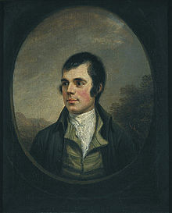

Robert Burns by Luc McCormack

Report about Robert Burns.
Robert Burns was born in 1759 in a house built by his father, William Burnes. His mother was Agnes Brown, the house was in Alloway in Ayrshire in Scotland.
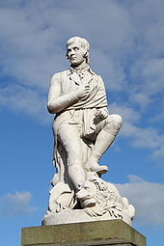
His Education.
His Father taught all his all his children, reading writing arithmetic history and geography. John Murdoch also taught Burns, he also went to Dalrymple Parish school then he finished his education with a tutor at Kirkoswald.

The family moved to Tarbolton to a farm called Lochlea. They lived there until his Father’s death in 1784.
